**Discover the Hidden Gems: Unleashing the Potential of Local Tourism**

**Abinaya Suresh (22Z203)**

**Geetha P K (22Z219)**

**Mithra K M (22Z238)**

**Moumitha K(22Z241)**

**Rithaniyaa B (22Z252)**

**Theetchanaa Raa (22Z269)**

**19Z215 - AICTE ACTIVITY POINT PROGRAMME**

report submitted in partial fulfillment of the requirement for the award of degree of

**BACHELOR OF ENGINEERING**

**Branch: COMPUTER SCIENCE AND ENGINEERING**

Of Anna University



## July 2022

**DEPARTMENT OF COMPUTER SCIENCE AND ENGINEERING**

**PSG COLLEGE OF TECHNOLOGY**

**(Autonomous Institution)**

**COIMBATORE – 641 004**

##### **PSG COLLEGE OF TECHNOLOGY**

**(Autonomous Institution)**

**COIMBATORE – 641 004**

**Discover the Hidden Gems: Unleashing the Potential of Local Tourism**

**Bona fide record of work done by**

**Abinaya Suresh 22Z203**

**Geetha P K 22Z219**

**Mithra K M 22Z238**

**Moumitha K 22Z241**

**Rithaniyaa B 22Z252**

**Theetchanaa Raa 22Z269**

**Dissertation submitted in partial fulfillment of the requirements for the degree of**

**BACHELOR OF ENGINEERING**

**Branch: COMPUTER SCIENCE AND ENGINEERING**

**of Anna University**

**JULY 2019**

**…....……………………..… …………..……………….**

**Dr. V Santhi Dr.G.SudhaSadasivam**

**Programme Coordinator Head of the Department**

**The candidate was examined in the review held on …………………**

**…………………….. …………………………..**

**Panel member 1 Panel member 2**

# **ACKNOWLEDGEMENT**

The AICTE Activity Point Programme project work had paved the way for personal development and creativity as proud volunteers with a sense of achievement and ready to take up projects having a social impact and creating digital awareness. We feel privileged to be associated with such a curriculum in **PSG College of Technology**.

We are extremely grateful to our **Principal Dr.K.Prakasan** for facilitating and extending untiring support in successful completion of the project. We are extremely glad to extend our gratitude to the department **Head Dr. G. Sudha Sadhasivam** and **Programme Co-ordinator Dr.V.Santhi** for offering us this opportunity which has made us to strengthen our soft skills, leadership qualities and team spirit. We extend our thanks to **Department Placement Co-ordinator Dr.K.Sathiya Priya** who has been the pillar of support.

We would like to take this opportunity to place my sincere thanks to our **Tutor ____** for her/his guidance in our project work and would also like to thank our **Panel members** who has spent their valuable time to aid us for coming out with the good project.

We would like to place our sincere thanks to _____ for offering us this opportunity and they have rendered their utmost support and made us aware of social issues that gave us the vision to have societal commitment leading to community service.

**CERTIFICATE**

Certified that this report titled **“Discover the Hidden Gems: Unleashing the Potential of Local Tourism”** for the **AICTE ACTIVITY POINT PROGRAMME** project work (19Z215) is a bonafide work of **“Abinaya Suresh (22Z203), Geetha P K (22Z219), Mithra K M (22Z238), Moumitha K(22Z241), Rithaniyaa B (22Z252), Theetchanaa Raa (22Z269)”** who have carried out the work for the partial fulfillment of the requirements for the award of the degree of Bachelor of Engineering in Computer Science and Engineering.

**Place:** Coimbatore

**Date :**

**Tutor Department Placement Coordinator**

**(Ms. S ARUL JOTHI) (Dr. K SATHIYA PRIYA)**

COUNTERSIGNED

**Dr.G.Sudha Sadasivam**

**HEAD**

**Department of Computer Science and Engineering**

**PSG College of Technology, Coimbatore - 641004**

# **CONTENTS**

**CHAPTER                                                              Page No.**

**Abstract.......................................................................................................... 4**

**1.**          **INTRODUCTION 5**

1.1          Introduction

1.2         Problem Statement

**2.**          **FEASIBILITY STUDY – INITIAL GROUNDWORK/SURVEY** **9**

2.1          Mapping with SDGs and AICTE themes

2.2 Mapping with National and State level schemes

2.3 Detailed case study

**3.**          **ACTIVITY PLAN 11**

3.1 Proposed Plan

3.2 Estimated time

**4.      IMPLEMENTATION / DESIGN 13**

4.1       Objective of the project

4.2     Design

4.3 Description of the solution

**5. ACTIVITY LOG 18**

**6.**      **APPENDIX (if applicable) 20**

# **ABSTRACT**

We hope to promote local tourism by developing a website that gives every person the required information for a trip to Coimbatore .This website contains information about various tourist spots and sightseeing along with restaurants and hotels which are available nearby.

The website will be designed in a manner where the user is allowed to share his/her opinions and views about the place or restaurants visited.

To make it much easier for the user to find directions we have ensured to provide it through google maps.

We will also be promoting about local tourism with the help of our website through social media. Our moto is to promote tourism among all the economic classes of people , so our website not only have information’s about expensive restaurants but also good budget friendly restaurants.

By promoting local tourism through our inclusive website and social media channels, we aspire to boost the economic growth of Coimbatore while creating unforgettable experiences for tourists. Our ultimate goal is to position Coimbatore as a premier travel destination that caters to the preferences and needs of all travelers, fostering sustainable and responsible tourism practices.

## 

## **CHAPTER 1**

**INTRODUCTION**

**1. 1 Introduction**

(Give introduction about the project work area and its benefits)

**1. 2 Problem Statement**

(Specify problem definition of your project work)

## **CHAPTER 2**

**FEASIBILITY STUDY**

**2.1      Mapping with SDGs and AICTE themes**

The long-term objectives listed below are part of the AICTE guidelines and our initiative, seeks to accomplish:

* Prepare and implement plan to improve local tourism through innovative methods

**2.2 Mapping with National and State level schemes**

(List the schemes mapping your project work)

**2.3 Detailed case study**

(Explain the existing projects relevant to your proposed project)

**CHAPTER 3**

**ACTIVITY PLAN**

* 1. **Proposed Plan**
* UI design : The design aspects of our website. The back-end involves the development of the website's functionality, such as database management, etc... The front-end focuses on creating the user interface (UI) design, making the website visually appealing, user friendly and easy to navigate.
* Collecting information: Gathering detailed information about various tourist places in our region and to visit those places and capture high-quality photographs that highlight their unique features. Additionally, collect information about hotels, guesthouses, restaurants, and other places to stay and eat. Note down details such as contact information, prices, amenities, and any other relevant information that would be helpful for potential visitors.
* Website Development: Implementing the design and develop the actual website. This involves coding the front-end and back-end components, integrating the collected information, photographs, and details about the places to stay and eat. Create the necessary pages, navigation menus, search functionality, and any other features required for a comprehensive tourism website
* Website Testing: Testing the website and checking for any bugs, errors, or issues in functionality, usability. Also conducting user testing to gather feedback on the website's design and usability and making any necessary adjustments or improvements based on the feedback received.

Once the website has been thoroughly tested and refined, it can be launched to the public.

**3.2 Estimated time**

3rd semester: UI design

The back-end and front-end development.

4th semester : Collecting information

Gather detailed information about various tourist places in our region and visit those places and capture high-quality photographs that highlight their unique features.

5th Semester: Website Development

Implementing the design and develop the actual website.

6th Semester: Website Testing

Checking for any bugs, errors, or issues in functionality, usability.

Once the website has been thoroughly tested and refined, it can be launched to the public.

**CHAPTER 4**

**IMPLEMENTATION / DESIGN**

**4.1    Objective of the project**

(Describe the objective of your project)

**4.2    Design** 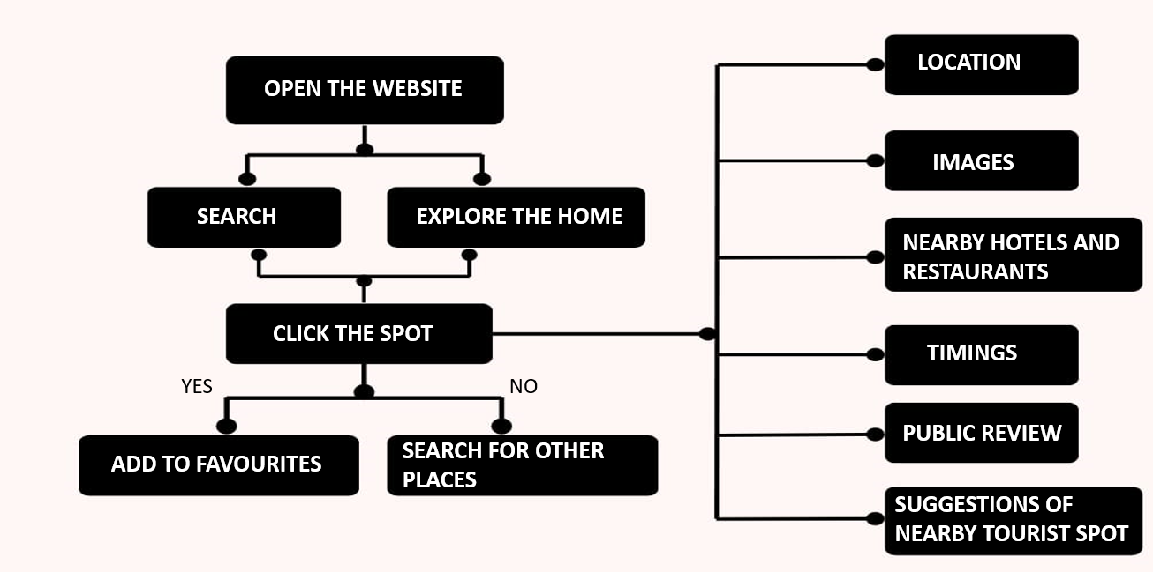

**4.3 Description of the solution**

* This website helps to promote local tourism by providing the location of unknown tourist spots and restaurants nearby.
* The user will find it easier to plan their trip since it provides all the required informations.
* Increase in local tourism leads to steady increase in the income of local communities, small businesses, tour operators, hospitality industry, local government, natural and cultural heritage, other industries, and suppliers.
* One of the other important benefits of sustainable tourism development is the improvements made to local infrastructure.
* If tourism increases in rural areas with less facilities ,improvement in facilities such as transportation, water supply, regular electricity will be made.

**CHAPTER 5**

**ACTIVITY LOG**

(Ensure to show your activity log covering minimum 60 hrs)

| **S. No** | **Activity list** | **Date/s of activity completed** | **No. of hours spent** |
| --- | --- | --- | --- |
|  |  |  |  |
|  |  |  |  |
|  |  |  |  |
|  |  |  |  |
|  |  |  |  |

**APPENDIX**

**(if applicable)**

(Attach any proof documents related to project activity like permission acceptance letter, certificates for attending, and any communication related documents from external sources)